Q1.

<html>

<head>

<title> Lab Question 1</title>

<style>

table, th, td

{

border: 0px solid black;border-collapse:collapse; Font-Size:30

}

.main{background-color:#0000FF;}

.new{ background-color: #6495ed;}

.next{ background-color: #b0c4de;}

</style>

</head>

<body>

<div>

<table>

<tr class=main>

<th>Item Name&nbsp;&nbsp;&nbsp;&nbsp;&nbsp;&nbsp;&nbsp;&nbsp;&nbsp;&nbsp;</th>

<th>Price</th>

</tr>

<tr class=new>

<td>Laptop</td>

<td>22,000</td>

</tr>

<tr class=next>

<td>Monitor</td>

<td>10,200</td>

</tr>

<tr class=new>

<td>Printer</td>

<td>< 7,100</td>

</tr>

<tr class=next>

<td><br></td>

<td><br></td>

</tr>

</div>

</body>

</html>

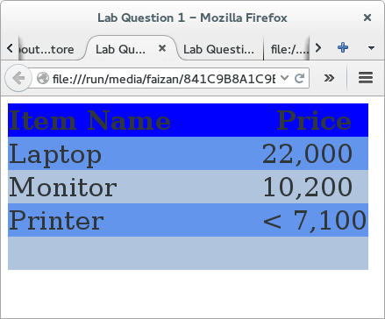

Q2.

<html>

<head>

<title> Lab Question 2</title>

</head>

<body>

<div>

<ul>

<li>Comedies</li>

<ul type=circle>

<li><a href="lab q1.html">A You Like It</a></li>

<li>All's Well That Ends Well</li>

<li>A Midsummer Night's dream</li>

<li>Twelfth Night</li>

</ul>

<li>Tragedies</li>

<ul type="circle">

<li><a href="lab q1.html">Hamlet</a></li>

<li>Macbeth</li>

<li>Romeo and Juliet</li>

</ul>

<li>Histories</li>

<ul type=circle>

<li>Henry IV(<a href="lab q1.html">email</a>)

<ul type=square>

<li>Part I</li>

<li>Part II</li>

</ul>

<li><a href="lab q1.html">Henry V</a></li>

<li>Richard II</li>

</ul>

</ul>

</div>

</body>

</html>

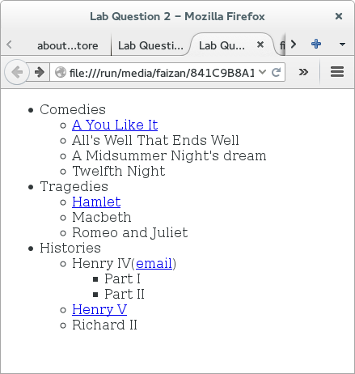

Q3.

<html>

<head>

<title>lab Question 3</title>

<style>

.align

{

float:left;

width:150px;

}

.align1

{

clear:both;

}

</style>

</head>

<body>

<div class="align1">

<div class="align">

<img src="coke.jpg" width=70% height=15%>

</div>

<div class="align">Coke<br>

200ml<br>

10% sugar<br>

newly launched<br>

</div>

</div>

<div class="align1">

<div class="align">

<img src="pepsi.jpg" width=70% height=15%>

</div>

<div class="align">Pepsi<br>

200ml<br>

20% sugar<br>

Comming Soon<br>

</div>

</div>

<div class="align1">

<div class="align">

<img src="lays.jpg" width=70% height=15%>

</div>

<div class="align">LAYS<br>

100mg<br>

Good Taste<br>

Launched<br>

</div>

</div>

</body>

</html>

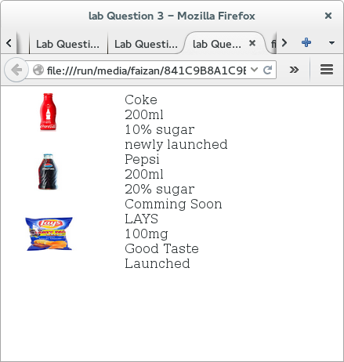

Q4.

<html>

<head>

<title>lab Question 4</title>

</head>

<body>

<div>

<form action="lab q4.html" method=post>

Name:<input type="text"><br/><br/>

Email:<input type="text"><br/><br/>

<input type="checkbox" checked>Subscribe to the News letter<br/><br/>

Format of the Email<br/><br/>

<input type="radio" name=g1 checked>HTML<br/><br/>

<input type="radio" name=g1>Plain Text

<br><br/>

Type of Subscription you want<br><br/>

<select>

<option>Standard-Free</option>

<option>Premium</option>

</select>

<br/><br/>

Comment to the Editor<br/>

<textarea rows="10" cols=30></textarea>

<br/><br/>

<input type=submit value=submit>

</div>

</body>

</html>

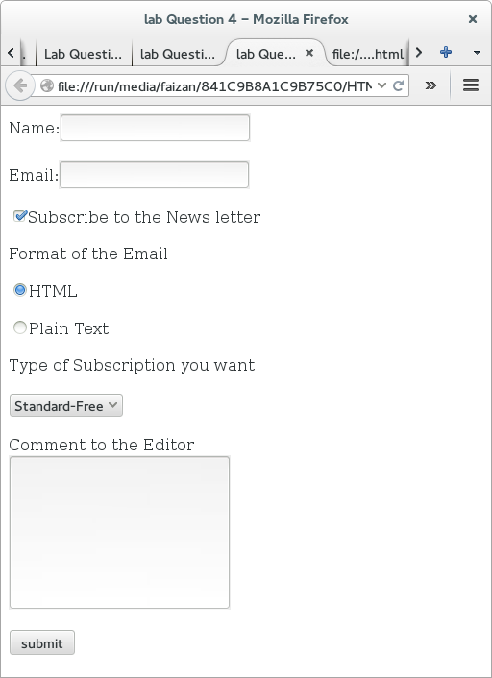

Q5.

<html>

<head>

<title>Lab Question 5</title>

<style>

.box1{

background-color:yellow;

position:absolute;

left: 50px;

top: 10px;

width:100px;

height:100px;

z-index:99;

}

.box2{

opacity:0.5;

background-color:blue;

position:absolute;

left: 80px;

top: 70px;

width:100px;

height:100px;

z-index :100;

}

</style>

</head>

<body>

<div>

<div class="box1"></div>

<div class="box2">TEXT</div>

</div>

</body>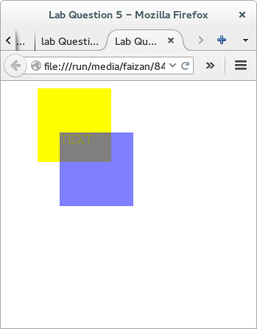

</html>